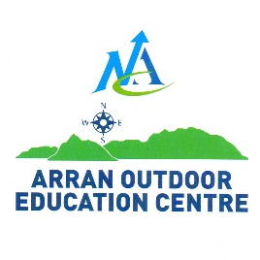
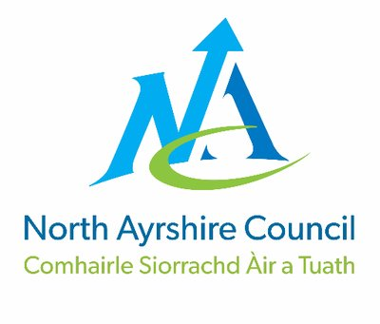
CONSENT FORM 2019-20

To be completed and signed by the parents / legal guardians of all young people under 18yrs old, and all adults participating in activities, or residing at Arran Outdoor Education Centre

North Ayrshire Council is collecting you or your child’s personal data to enable you or your child to benefit from the Arran Outdoor Education Centre, and in case of an emergency to protect vital interests of you or your child. Arran Outdoor Education Centre, will not share any of your or your child’s personal data collected with any other external organisation unless required or permitted to do so by law.
For further details please view the Privacy Policy on the Council’s website; https://www.north-ayrshire.gov.uk
Name of Person |  |  | Age: |  |  |  | Date of Birth:
Address: | Postcode:
School Name: |  |  |  |  |  | Date of Course:
Emergency Contact Details
1st Emergency Contact Name: |  |  |  | 2nd Emergency Contact Name
Home Phone Number: |  |  |  | Home Phone Number:
Work Phone Number |  |  |  | Work Phone Number:
Mobile Phone Number |  |  |  | Mobile Phone Number:
Doctor’s Name: |  |  |  |  |  | Doctor’s Tel:
Doctor’s Surgery Address:
Does the attendee have any historical or on-going medical conditions or treatments which may be adversely affected by physical exercise or weight carrying, or any problems with circulatory, respiratory, nervous or skeletal systems?
Please tick YES NO
(If your answer is YES, please provide details, and continue overleaf if necessary)

Does the attendee have any allergies to any medication or food? Please tick YES NO
(If your answer is YES, please provide details, and continue overleaf if necessary)

Please tick Yes or No to the following;
- Water confident? YES NO
- Agree to receive any emergency medical treatment. YES NO
- Agree to any first aid that may be necessary. YES NO
- Agree to the administration of antihistamines, and paracetamol as appropriate. YES NO
- Agree to photographs of the attendee being used anonymously, for promotional YES NO
information, including website and social media?
Please Turn Over
Are there any other relevant physical and/or mental health, social, or behavioural issues that we should know relating to the person above?
(Please provide details, and continue below if necessary)

At Arran Outdoor Education Centre, we are committed to ensure that we are meeting your child’s needs with regards to allergen information. To ensure we have the correct information for your child’s meal requirements, could I please ask you to provide information on any allergies or special dietary requirements -
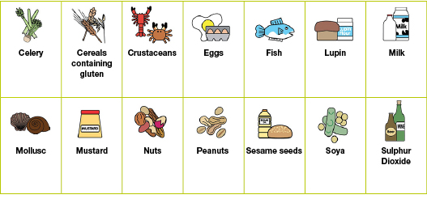

Please tick any food allergies that
apply from the list.

Required Diet Vegetarian Vegan No red meat

Any other intolerances/allergies/cultural requirements:

Please detail any additional information that may be relevant to your child’s residential visit to Arran Outdoor Education Centre.
I confirm that I have received and fully understand the details of the course at Arran Outdoor Education Centre which my child / I will participate in. I agree to participate in the activities and acknowledge that there is an inherent risk in these activities. I accept the need for responsible and obedient behaviour. I accept that in certain circumstances (e.g. weather) the content of the programme may change. I have read and agree with the booking terms described in the letter to parents.
Name of Parent / Legal Guardian
Or Participating Adult: Signature:

RETURN COMPLETED FORM TO COURSE ORGANISER – FORMS TO BE SENT TO AOEC 8 WEEKS PRIOR TO START DATE

